**AUTOMATIC GARAGE DOOR OPENING USING ARDUINO**

**Introduction**

In the contemporary world we are living in mechanized world. All our work is done with the help of machines and equipments. We cannot think of a life in which machines are not there, therefore we always think of machine which further reduces the human effort to minimum.

This is theme of our project i.e. to reduce human effort and save time with the help of simple and useful device named '**Arduino Based Opening Garage System** '. It contains a mechanized shutter having motor to drive it, whose control is executed by a Bluetooth based microcontroller (arduino).

**Why did we decide to make it?**

Since our project was needed a taste of electronics basics so we decided to blend mechanical with electronics, thus on many thoughts and discussion within group, we proposed project named 'ARDUINO BASED GARAGE OPENING SYSTEM USING BLUETOOTH MODULE'. This project satisfies human needs to great extent as stated earlier.

The project consists of a motor driven gate which is being controlled by Bluetooth module. The main objective of project is to control the function of motor using wireless system.

**Material and Methods**

Components used:

* Hardware:

|  |  |  |  |
| --- | --- | --- | --- |
| S. No. | Components | Picture | Description |
|  | Arduino Uno |  | It is micro controller which is used to interfacing the devices with pc. Here we are using the Arduino for interfacing Bluetooth module with driver. Driver is being controlled by Bluetooth which is programmed in Arduino to run stepper motor in either direction. |
| 2. | Stepper Motor |  | Stepper motor is used in this project as it can rotate in either direction. Since we require sliding the gate in both directions, therefore we used stepper motor. Stepper motor has proper step angle i.e. at each step motor rotate a fixed angle (here we have 1.6 degree). Stepper motor provides torque, which rotate lead screw. |
| 3. | Bluetooth Module |  | It is used to connect with mobile and control the motor rotation. |
| 4. | Lead Screw |  | It is used to hold gate and connect it with motor. |
| 5. | Driver (A3967) |  | It is used to connect motor with Arduino and provide proper power supply (here we have used 12V lead battery to give power supply). |
| 6. | Coupling |  | It is used to connect motor with lead screw. |
| 7. | P.C.B Board |  | This board is used to fix the wiring by soldering so that it does not get tangled or leave during working of machine. |

Mechanical Hardware

1. Nut
2. Wooden plank

* Software:

1. Arduino IDE

The Arduino Integrated Development Environment - or Arduino Software (IDE) - contains a text editor for writing code, a message area, a text console, a toolbar with buttons for common functions and a series of menus. It connects to the Arduino and Genuine hardware to upload programs and communicate with them.

2. Fritzing

Fritzing is an open-source hardware initiative that makes electronics accessible as a creative material for anyone. It is a software tool and a community website for Processing and Arduino, fostering a creative ecosystem that allows users to document their prototypes, share them with others, teach electronics in a classroom, and layout and manufacture professional pcbs

Method:

Step 1: Mechanical Modelling

Step 2: Circuit designing

The connections are as follows:

1. The positive pin of Battery is connected to V-IN of Arduino.
2. The D-8 pin of Arduino is connected to DIR.
3. The D-9 pin of Arduino is connected to STEP.
4. The Ground of Breadboard is connected to OUT 1B terminal of Motor Driver.
5. The OUT 1A pin of motor driver is connected to B terminal of motor.
6. The OUT 2A pin of motor driver is connected to A terminal of motor.
7. The OUT 2B pin of motor driver is connected to C terminal of motor.
8. The VCC of Bluetooth module is connected to VCC of Breadboard.
9. The Ground of Bluetooth module is connected to Ground of breadboard.
10. The RX pin of Bluetooth module is connected to TX pin of Arduino.
11. The TX pin of Bluetooth module is connected to RX pin of Arduino.

Step 3: Update code in Software

**Schematics**

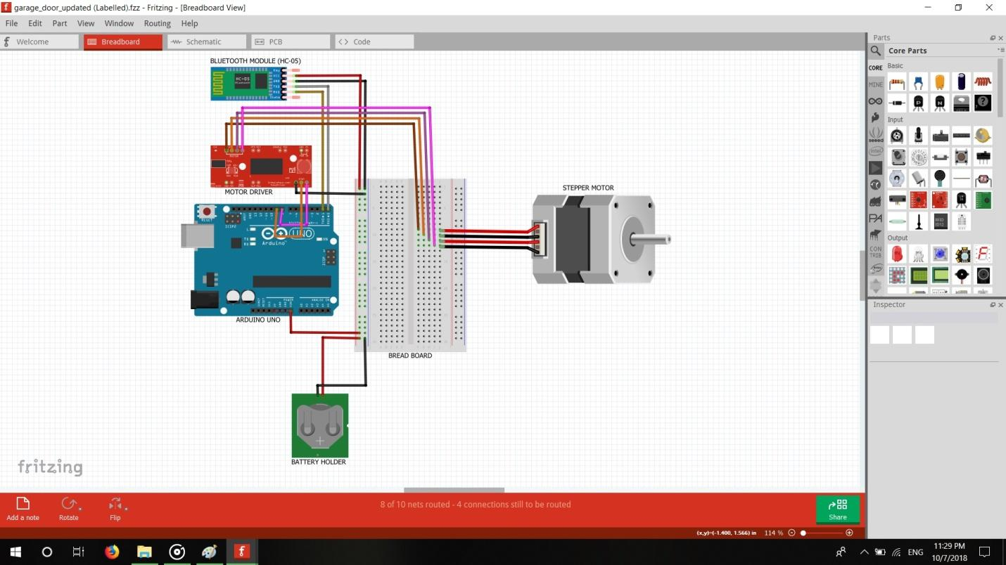

**Cad Model**

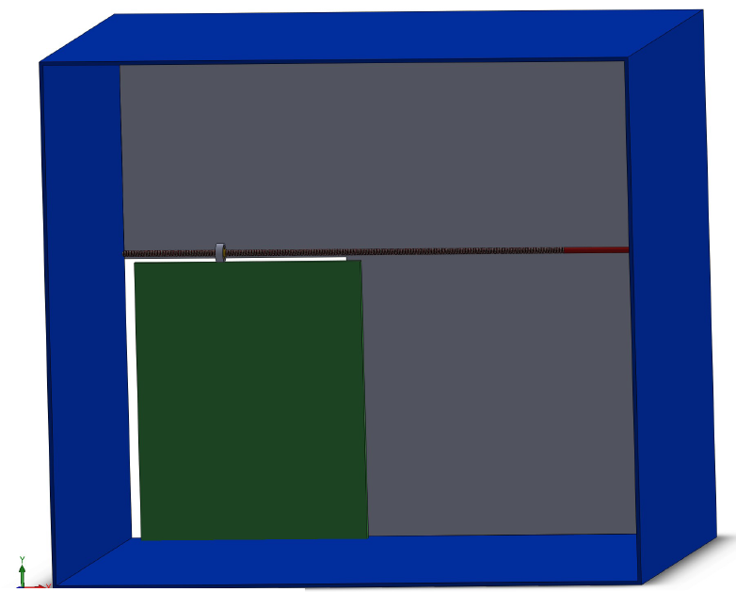 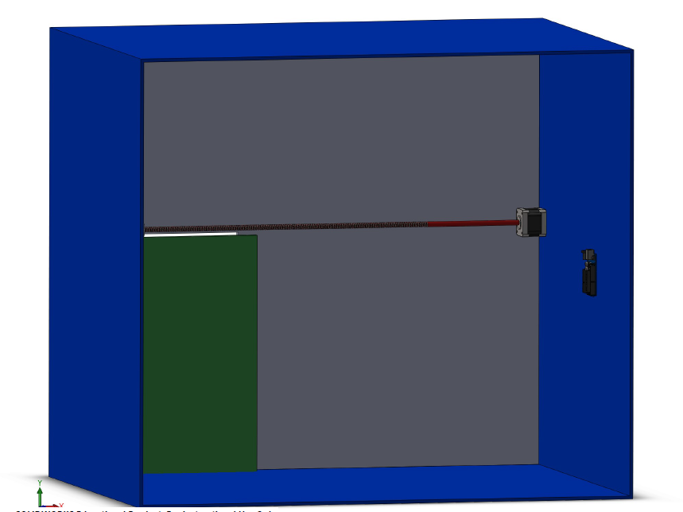

**Future scope**

* The future scope of this project is instalment of sensor to sense any obstacle during opening and closing of gate to avoid any mishaps.
* It can also be endorsed with light sensor to light up garage as it opens.
* Automatic garage door can also be useful in warehouses where people generally have their hands full contributing to safety and efficiency by making it easier for people to get around.